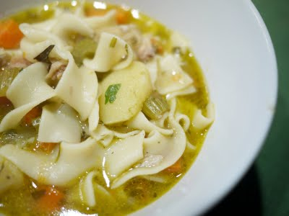
Homemade Turkey Soup

Ingredients:
6 lb | turkey breast. It should have some meat (at least  2 cups) remaining on it to make a good, rich soup
2 | medium onions
3 | stalks of celery
1 tsp | dried thyme
1/2 tsp | dried rosemary
1/2 tsp | dried sage
1 tsp | dried basil
1/2 tsp | dried marjoram
1/2 tsp | dried tarragon
1/2 tsp | salt
to taste | black pepper
1/2 lb | Italian pastina or pasta
Each serving provides:
Calories: | 226
Total fat: | 5 g
Saturated fat: | 1 g
Cholesterol: | 93 mg
Sodium: | 217 mg

Directions:
- Place turkey breast in a large 6-quart pot. Cover with water, at least 3/4 full.
- Peel onions, cut in large pieces, and add to pot. Wash celery stalks, slice, and add to pot also.
- Simmer covered for about 2-1/2 hours.
- Remove bones from pot. Divide soup into smaller, shallower containers for quick cooling in the refrigerator.
- After cooling, skim off fat.
- While soup is cooling, remove remaining meat from turkey bones. Cut into pieces.
- Add turkey meat to skimmed soup along with herbs and spices.
- Bring to a boil and add pastina. Continue cooking on low boil for about 20 minutes until pastina is done. Serve at once or refrigerate for later reheating.
Yield: About 4 quarts of soup (16 servings) – Serving Size: 1 cup

